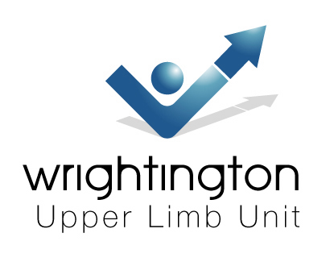

TRICKS AND TIPS

IN HAND AND WRIST SURGERY

4th & 5th December 2008

WRIGHTINGTON HOSPITAL
CONFERENCE CENTRE
HALL LANE
APPLEY BRIDGE
WIGAN WN6 9EP
LANCASHIRE

THURSDAY – 4th December 2008

0830 Registration
0855 Welcome

ARTHRITIS and ARTHROPLASTY
Chair Mr Mike Hayton

0900 DRUJ OA Surgical options : When, Why and in Whom ? Prof John Stanley
0920 STT OA : Surgical options treatment and pitfalls Mr Raj Murali
0940 PRC or 4 corner fusion : When, Why and in Whom ? Mr Anthony Hearnden
1000 What’s new in biologic therapy Prof Rob Moots
1020 Top tips in total wrist arthroplasty Mr Ian Trail
1040 Top tips in PIPJ arthroplasty Mr Ian Trail

11.00 COFFEE

ARTHROSCOPY, INSTABILITY
Chair Mr Raj Murali

1130 Top tips in wrist arthroscopy Mr Doug Campbell
1150 Top tips and tricks in TFCC : Repair and Debride Mr Doug Campbell
1210 How I assess wrist ligament instability Dr Bill Geissler
1230 Top tricks for the Brunelli Mr Mike Hayton

13.00 LUNCH

SCAPHOID

Chair Mr Joe Dias

1400 How I manage a scaphoid fracture Prof Joe Dias
1420 Top Tips and tricks in percutaneous scaphoid Mr Carlos Heras-Palou
1430 Top Tips and tricks in open non union scaphoid Mr Mike Hayton
1440 Top Tips in percutaneous bone grafting scaphoids Mr Jeremy Fields

1500 WORKSHOPS: Total Wrist Replacement
Mr Ian Trail Universal
Prof Michel Boeckstyns SBi

Distal Ulnar Head Replacement
Prof John Stanley Ascension

Acutrak SLIC screw
Dr Bill Geissler Acumed

15.45 TEA

1600 Experts chew the fat : an honest discussion of cases All

1645 Keynote address : What’s changed in my practice and why? Dr Bill Geissler

1730 CLOSE

Course dinner - 19.30 for 20.00

FRIDAY – 5th December 2008

SOFT TISSUE

Chair; Mr Anthony Hearnden

0900 My UK experience with the NC Stat Mr Paul Davy
0910 The American experience Dr Louis Jurist
0920 Potential problems with surgeon performed NCS Dr Andy Marshall
0940 Top tricks in tendon transfers Mr Vinod Kumar
1000 TBC Mr Mike Craigen
1020 Top tips in Dupuytren’s surgery Mr David Warwick
1040 Simple Flaps for simple folk Mr Vinod Kumar

11.00 COFFEE

MISC

Chair: Prof John Stanley

1130 Tips and tricks in distal radial fractures Mr James Warner
1150 Top tips in radial osteotomies Mr Carlos Heras-Palou
1210 Lateral approach for PIPJ arthroplasty Prof Michel Merle
1230 Surgical swan neck options Prof Michel Merle
1250 Top tricks in MCP and PIPJ releases Mr David Warwick

1315 LUNCH

1400 WORKSHOPS: Small joint and anchors

Finsbury PIP – Mr Ian Trail
Ascension PIP - Prof John Stanley
SBi PIPJ – Prof Michel Boeckstyns
Mitek– Prof Michel Merle

1500 Experts chew the fat : an honest discussion of cases All

1530 Keynote address: What’s changed in my practice and why? Prof John Stanley

1615 CLOSE

